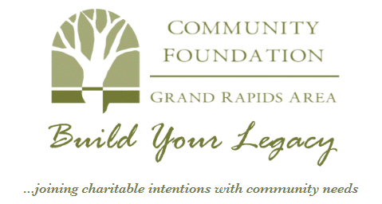

Position Title: Development and Communications Manager
Reports To: Executive Director
FLSA Status: Exempt
Date: November 2025

Position Summary: The position is the senior staff person responsible for resource development and promotional efforts of the Foundation. This person oversees donor services, fundraising, gift recognition, special events, and marketing activities. This role is responsible for creating new funds and delivering service to donors. This person works collaboratively with team members to establish and execute a plan for significant growth. This position will improve the utilization of data and planning with an emphasis on the cultivation of existing donors and the acquisition of new donors to raise the resources and awareness to carry out the mission of the Foundation.
General Responsibilities:
- Main responsibilities are fundraising and donor relations, marketing and communications and community engagement.
- Provide direction and establish long-and short-range goals in conjunction with the Foundation’s strategic plan.
- Design, implement and evaluate comprehensive development strategies and programs that support the overall goals and objectives of the Foundation.
- Create, integrate and adapt technological platforms and strategies to improve the donor experience.
- Represent the Foundation in all aspects of external outreach and educational opportunities.
- Assist the Executive Director to establish revenue and implement performance goals, objectives, action plans, and benchmarks for the work and programs of the Foundation.
- Use data analytics to drive decision making for the overall assessment of the Foundation’s work.
- Implement a continuous improvement philosophy that includes benchmarking programs, peer-based performance metrics, and outcomes that support high performance standards.
- Collaborate with the Executive Director on creating and maintaining relationships with regional financial advisors and Foundation stakeholders.
- Create and maintain systems to assure that donor instructions are documented and followed.
- Oversee the internal and external marketing plan for the Foundation.
- Frequently collaborate with donors, businesses and organizations where appropriate.
- Collaborate with the Executive Director to drive new growth opportunities. Identify, prioritize, develop and launch new projects, services and business models that elevate the donor and volunteer experience.
- Perform other duties as assigned by Executive Director.
Education and/or Experience:
- Experience and exposure to the nonprofit sector through employment, board experience, etc.
- Experience and understanding of non-profit financial issues and investment management.
- Understanding of investments, banking and community foundation programming.
- Understanding of donor and fund development concepts.
- Experience with fundraising and planned giving preferred.
- Experience with public speaking and ability to provide presentations to groups of people.
- Experience in managing and supervising employees.
- Knowledge of, experience with and a passion for the Greater Itasca Area communities and community issues.

Essential Skills & Abilities:
- Must have excellent professional skills and abilities, , verbal and written communication, leadership skills, interpersonal skills, conflict management skills, cultural competence and emotional intelligence.
- Established abilities in decision making and organizational and Board-level communications
- Ability to build and work with teams.
- Proficient in the Microsoft Office Suite of programs.

Typical Physical Requirements:
- Frequent travel required (primarily driving through the State of Minnesota)
- Sitting up to 6 hours per day
Ownership of Material:
All records, reports, publications and original work prepared while assisting GRACF will remain the property of GRACF.
Performance Indicators:
The responsibilities and personal qualifications as presented in this job description will be utilized as a measuring tool in the Development and Communications Manager’s performance evaluation. To further articulate annual performance expectations, the Development and Communication Manager shall meet with the Executive Director annually to evaluate performance.
Confidentiality
I understand that any and all information regarding names or personal information of all clients, donors, staff, volunteers, or any other person I may read or hear about while at the Grand Rapids Area Community Foundation shall be held in strict confidence by ne as a staff member of GRACF. I agree to not disclose or use to my advantage any of this confidential information.

Personnel Handbook
I have read and understand the job description for the position of Development and Communications Manager and the Personnel Handbook. I understand that the terms of this position can be changed by the Community Foundation at any time at its sole discretion. All hiring is presumed to be “at will”; that is, the employer is free to discharge individuals “for good cause, or bad cause, or no cause at all,” and that I, as an employee, am equally free to quit or otherwise cease to work. A two week notice from either side is requested.

_____________________________________________
Employee Signature Date

_____________________________________________
Employee Printed Name

_____________________________________________
Executive Director Signature Date

_____________________________________________
Executive Director Printed Name

